LOGBOOK 14

Team 1 : Student Enegy – Hand Ball

Artist :

* Membuat konsep poster

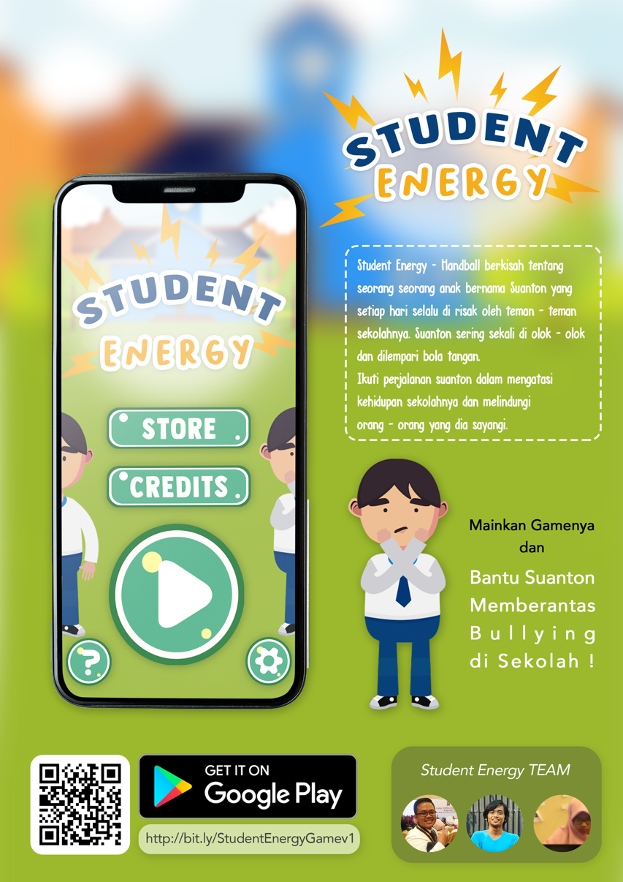

Programmer :

Upload ke playstore

Game Design :

* Game Design Document Update
* Mechanic Update
* Main Menu
* Main Menu Development
* Fix Mechanic.